Children explore the six key religions from around the world.

Every September or October sees the Harvest Celebration take place. Donations of food are sent into school and then collected by the Black Country Food Bank. An assembly is held and activities completed for Harvest during RE lessons.

Medium Term Plans include RE coverage for each term.

‘Open the Book’ assemblies take place every half term with people coming in from Holy Trinity Church to share a different Christian story.

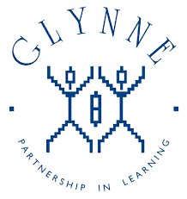

Children in Reception complete the Festivals and Celebrations learning journey during Autumn 2 exploring Diwali and Christmas.

Learning walks enable subject leader to see RE being delivered and talk to the children about RE.

RE subject leader completes annual action plan which is reviewed and shared with governors.

Artefacts are used in some lessons to support learning and understanding.

Glynne Primary School

What does

Religious Education look like?

KS2 take part in a carol concert in December at Holy Trinity Church. They will have spent time during Autumn 2 learning specific songs during class and assembly time.

Whole school assemblies take place to discuss the meaning of Harvest, Advent, Christmas and Easter and to look at why we celebrate them.

KS1 have completed Christmas performances celebrating the birth of Jesus.

Easter bonnets are made at home by children in KS1 and EYFS and brought in to share with their friends. Children have the opportunity to spend some time exploring Easter activities.

The curriculum leader has the opportunity to attend the Dudley Primary

Co-ordinators meetings termly, discussing updates and ideas with other staff around the borough.